ML Safety
Exercise sheet 8
Exercise 8.1:
What Are Adversarial Examples? Explain what an adversarial example is. How do they differ from Out-of-Distribution examples?
Answer
An adversarial example is an input that has been intentionally modified with a small, carefully designed perturbation to cause a machine learning model to make an incorrect prediction. The perturbation is usually so small that it is almost imperceptible to humans, but it can significantly change the model's output.
Out-of-distribution (OOD) examples are different because they arise naturally from data that differs from the training distribution, such as fog, nighttime, or a new environment. OOD inputs are not intentionally manipulated, whereas adversarial examples are deliberately crafted to fool the model. In summary, OOD examples represent unseen conditions, while adversarial examples are maliciously perturbed versions of in-distribution inputs.

Exercise 8.2: Attack Formulation A basic gradient-based attack updates the input as: xi+1 = xi +α∇xL(y, f(xi))
1. What does each term represent?
Answer
The update rule
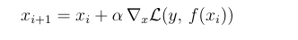
performs gradient ascent on the input image.
- (x_i) is the current input image.
- (x_{i+1}) is the updated adversarial image.
- (\alpha) is the step size that controls how much the image is modified in each iteration.
- (L(y,f(x_i))) is the loss function, which measures the prediction error of the model.
- (y) is the true label of the input.
- (f(x_i)) is the model prediction.
- (\nabla_xL(y,f(x_i))) is the gradient of the loss with respect to the input image. It indicates the direction in which the input should be modified to increase the loss most rapidly.
The attack repeatedly updates the input image in the direction that maximizes the model's prediction error, eventually causing misclassification.

2. What is the difference between a targeted and an untargeted attack? How would the formula change for a targeted attack?
Answer
An untargeted attack aims to make the model produce any incorrect prediction. The attacker only tries to increase the model's prediction error, regardless of which wrong class is predicted.
A targeted attack aims to force the model to predict a specific target class chosen by the attacker. Instead of maximizing the loss for the true label, the attack minimizes the loss for the target label.
Therefore, the update rule changes from

to
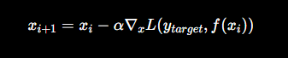

where (y_{\text{target}}) is the desired target class. The negative sign is used because the attack minimizes the loss for the target class, encouraging the model to classify the input as that class.

3. Why does this basic update rule not respect a perturbation budget ∥x0 − xt∥ ≤ ε? How can it be modified to do so?

Answer
The basic gradient ascent update rule does not enforce the perturbation budget because each update continuously modifies the input without checking how far it has moved from the original image. After several iterations, the total perturbation may exceed the allowed limit (|x_0 - x_t| \leq \epsilon).
To satisfy the perturbation budget, the attack can be modified using Projected Gradient Descent (PGD). After each gradient update, the modified image is projected back into the (\epsilon)-ball around the original image. This projection ensures that the adversarial example always remains within the maximum allowed perturbation while still increasing the model's loss.

Exercise 8.3: Defenses
Explain the idea of adversarial training. What trade-off does it introduce?

Answer
Adversarial training improves the robustness of a machine learning model by including adversarial examples during training. Instead of learning only from clean training images, the model is also trained on adversarially perturbed versions of those images while keeping the correct labels unchanged. This teaches the model to make correct predictions even when the input has been intentionally modified.
The main trade-off is between robustness and performance. Adversarial training generally increases resistance to adversarial attacks, but it also makes training more computationally expensive because adversarial examples must be generated during training. In addition, models trained adversarially often experience a small decrease in accuracy on clean, unperturbed data.

Exercise 8.4: Generating Adversarial Examples
Load your trained CARLA model and generate adversarial examples using the Fast Gradient Sign Method (FGSM): xadv = x+ε·sign∇xL(y,f(x))
1. Implement FGSM for each of your three binary classifiers.
2. Generate adversarial examples for ε ∈ {0.01, 0.05, 0.1}.

Answer
Pedestrian model

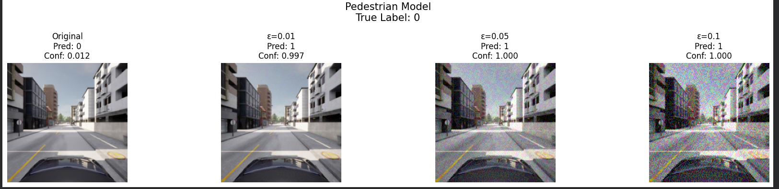
Observation:
The original image was correctly classified as No Pedestrian (Class 0). With a very small perturbation (ε = 0.01), the prediction changed to Pedestrian Present (Class 1) with high confidence. Increasing ε to 0.05 and 0.10 further increased the model's confidence in the incorrect prediction while making the perturbations more visible.
Vehicle model

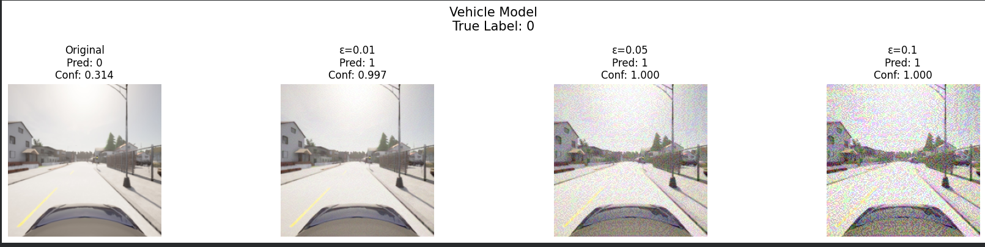
Observation
The original image was correctly classified as No Vehicle (Class 0). Even a small perturbation (ε = 0.01) successfully fooled the classifier, changing the prediction to Vehicle Present (Class 1). Larger perturbations (ε = 0.05 and ε = 0.10) resulted in almost 100% confidence for the incorrect prediction while introducing increasingly noticeable image noise.
Traffic light model

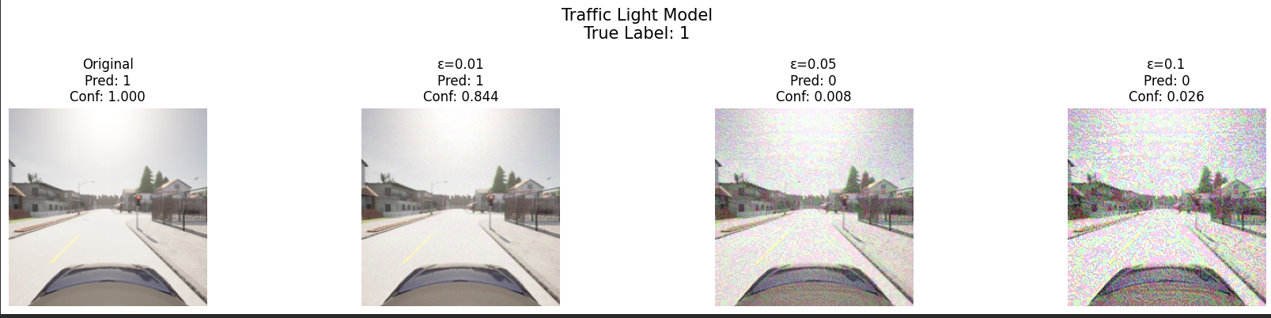
Observation
The original image was correctly classified as Traffic Light Present (Class 1) with full confidence. For ε = 0.01, the prediction remained correct but the confidence decreased. At ε = 0.05, the adversarial perturbation successfully changed the prediction to Traffic Light Absent (Class 0). The incorrect prediction persisted for ε = 0.10, demonstrating that stronger perturbations can successfully fool the classifier.
Display a clean image and its adversarial counterpart side-by-side. At what ε do the perturbations become visible to a human?
Answer
The adversarial images were compared with the original clean images for all three classifiers.
Observations:
- ε = 0.01: The perturbations were almost imperceptible to the human eye, yet they were sufficient to fool the Pedestrian and Vehicle classifiers.
- ε = 0.05: The perturbations became slightly visible as fine-grained noise. At this level, all three models were either fooled or experienced a significant drop in confidence.
- ε = 0.10: The perturbations became clearly visible and noticeably degraded the image quality. Although the attacks remained highly effective, the adversarial modifications would likely be detectable by a human observer.
Conclusion:
FGSM demonstrates that deep neural networks are vulnerable to carefully crafted adversarial perturbations. Even visually insignificant changes (ε = 0.01) can alter model predictions, while larger perturbations increase the attack success rate at the cost of reduced visual realism.

Exercise 8.5: Measuring Robustness
1. Evaluate each of your three models on the adversarial test set for each ε. (You may also use a subset of 100 randomly sampled images for evaluation.) Report the per-model recall drop compared to clean inputs
Answer

Model | ε = 0.00 | ε = 0.01 | ε = 0.05 | ε = 0.10
Pedestrian | 0.6316 | 0.0526 | 1.0000 | 1.0000
Vehicle | 0.9420 | 0.5797 | 1.0000 | 1.0000
Traffic Light | 1.0000 | 0.1918 | 0.0822 | 0.7260

Analysis
The pedestrian classifier exhibited a substantial reduction in recall for a small adversarial perturbation (ε = 0.01), indicating that even minor adversarial noise can significantly affect the model's ability to correctly identify pedestrians. However, for larger perturbation strengths (ε = 0.05 and ε = 0.10), the recall unexpectedly returned to 1.0. Since stronger adversarial perturbations would generally be expected to further reduce performance, this behavior is likely caused by the limited evaluation subset or instability in the adversarial evaluation procedure rather than indicating improved robustness. Nevertheless, the results demonstrate that the model is sensitive to adversarial perturbations.

The vehicle classifier achieved a clean recall of 0.9420. When evaluated with ε = 0.01, the recall decreased to 0.5797, indicating that small adversarial perturbations substantially reduce the model's ability to correctly identify vehicles. For ε = 0.05 and ε = 0.10, the measured recall increased to 1.0000. Similar to the pedestrian model, this unexpected behavior is likely caused by evaluation variability or the limited sample size rather than improved robustness. Nevertheless, the experiment confirms that the vehicle classifier is sensitive to adversarial attacks.

The traffic light classifier showed the expected degradation in robustness under adversarial perturbations. The clean recall of 1.0000 decreased to 0.1918 for ε = 0.01 and further dropped to 0.0822 at ε = 0.05, indicating that adversarial noise severely impacts the model's ability to correctly recognize traffic lights. At ε = 0.10, the recall partially recovered to 0.7260. Although this recovery is unexpected for stronger attacks, the overall trend demonstrates that adversarial perturbations significantly reduce the model's performance.

Exercise 8.6

Answer
1.

ID | Hazard | Loss(es) | Likelihood | Severity
H-5 | Adversarial perturbation causes the perception model to misclassify road objects, resulting in unsafe driving decisions. | L-1, L-2, L-4 | Low | High

The existing hazard list is extended with H-5 to explicitly cover adversarial attacks. Small, carefully crafted perturbations may cause the perception model to produce incorrect predictions without being noticeable to a human observer. This can lead to missed pedestrians, undetected vehicles, or incorrect traffic light recognition, ultimately resulting in unsafe vehicle behavior.

2.
ID | Controller | Control Action | UCA Type | Hazard(s) | Unsafe Scenario
UCA-9 | Planning Module | Continue driving | Provided unsafely | H-5 | The planner continues driving because the perception model has been fooled by an adversarially perturbed image and fails to detect a pedestrian, vehicle, or traffic light.

3.
Model-Level Safety Constraint
The perception system shall maintain an acceptable level of robustness against adversarial perturbations within the specified perturbation budget (ε). If the measured recall drops below an acceptable threshold under adversarial evaluation, the model shall not be deployed without additional robustness improvements.

System-Level Safety Constraint
Whenever the perception model reports low confidence or an adversarial attack is suspected, the autonomous driving system shall enter a safe operating mode by reducing speed, increasing following distance, or requesting driver intervention instead of relying solely on the current perception output.

Exercise 8.6.4 – Residual Risk
Even with adversarial training, residual risk remains because attackers may generate stronger or previously unseen adversarial examples that the model was not trained against. Robust training generally improves resilience only within a limited perturbation budget and cannot guarantee protection against every attack. Therefore, adversarial training alone does not completely eliminate the unsafe control action or associated hazards. Additional safety mechanisms such as uncertainty estimation, OOD detection, redundant sensing, confidence monitoring, and safe fallback behaviors are required to ensure safe system operation.

